**Evaluation Portfolio**

**Objective:**

To do analysis for the top 5 IIT’s based on its intake, placement, funding and spending pattern for the years 2017 to 2020.

**Theory**:

Data of UG 4yrs course for the top 5 IIT’s was done. It was segregated and written in Ms Excel which was later used for visualization.

Top 5 IIT’s

* IIT Madras
* IIT Delhi
* IIT Bombay
* IIT Kanpur
* IIT Kharagpur

**Tools**:

* Ms Excel
* Tableau

**Analysis**:

1. **Intake to Placement**

* Data from the year 2014 to 2020 was taken.
* Pie charts were used to show the no. of student’s intake to placement in each year.
* Visualization [Intake Vs. Placement](https://public.tableau.com/views/IITAnalysis/Dashboard1?:language=en-US&:display_count=n&:origin=viz_share_link)

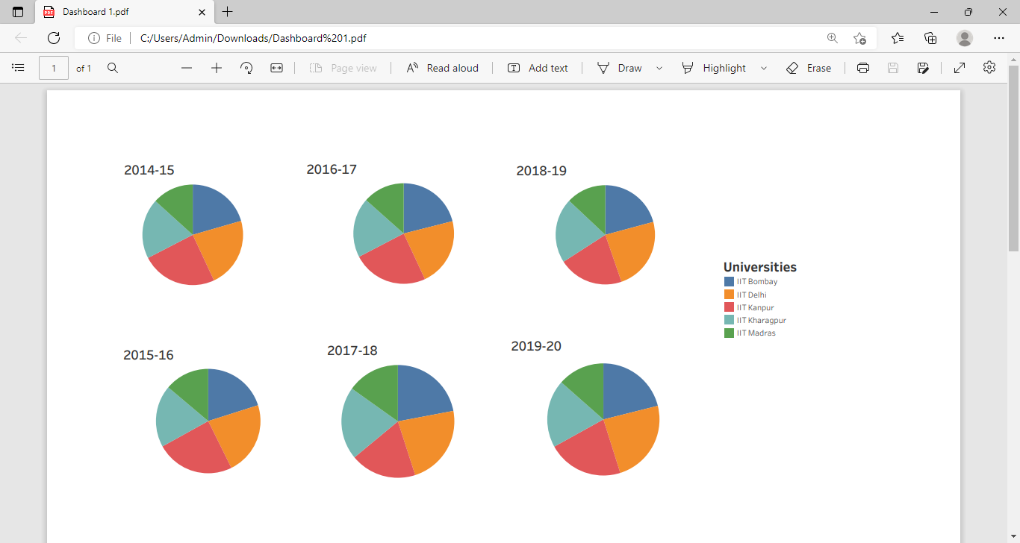

* Analysis made
* IIT Kanpur has the highest intake every year but the placement rate up to 2017 was good but due to certain reasons as higher studies or backlog the placement rate dropped down drastically.
* IIT Kharagpur the intake rate was constant up to 2017-18 after which there was an increase in it’s which could have been because of the high demand. Placement rate was had dropped in the year 2017-18.
* IIT Delhi intake rate constant up till 2020 which could have been due to increase in demand or the addition of new courses and placement rate dropped again after 2017.
* IIT Bombay intake is never constant but the limit up to 800 students per year is kept and placement pattern is the same for this university as all the above.
* IIT Madras had a fixed intake up till 2018 after which drastic increases has been noted and placement rate drop is the same as for the above universities.
* From this conclusion made is that most of students preferred higher studies or off campus placement after after the year 2017.

1. **Funding to Expenditure**

* Data from the year 2017 to 2020 was taken.
* Bar plots are used to show the highest funding to expenditure for each IIT in the given year.
* Visualization - [Expenditure Vs. Funding](https://public.tableau.com/views/IITExpenditureVsFunding1/Dashboard1?:language=en-US&publish=yes&:display_count=n&:origin=viz_share_link)

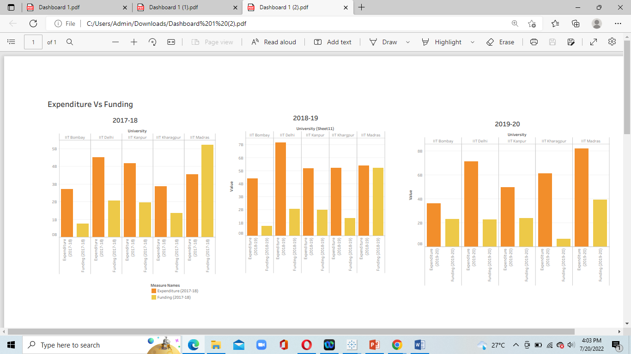

* Analysis made
* For the year 2017-18 IIT Madras had the highest funding even after having the least number of funding agency while IIT Delhi had the most expenditure having the maximum number of funding agency in.
* For the year 2018-19 IIT Madras had the highest funding even after having the least number of funding agency while IIT Delhi had the most expenditure having the a good number of funding agency in.
* For the year 2018-19 IIT Bombay had the highest number of funding agencies yet the least funding.
* For the year 2019-20 IIT Madras had the highest funding after having a good number of funding agency and it also had the highest expenditure.
* For the year 2019-20 IIT Delhi had maximum funding agencies yet least funding and IIT Kharagpur had least funding but amount equivalent to IIT Bombay and Delhi.

**Conclusion:**

* IIT Kanpur and IIT Delhi have the maximum student intake to placement ratio
* Expenditure of IIT Delhi is the most due to excess teaching as well as non-teaching staff.